# 

# ITT-306 Blockchain Demo Worksheet

**Part 1: Blockchain Introduction**

Watch “How Does a Blockchain Work? Blockchain Example and Explanation.” Summarize the process of making a public ledger and describe the key ideas that make it work.

**Part 2: Demonstrate the Hashing Functions of Java**

It is recommended that you install a Java compiler such as Eclipse for Java located in the Course Materials. You may also use an online Java compiler like Compile Java (https://www.compilejava.net/) or Online GDB (https://www.onlinegdb.com/)

1. Code the following Java program. This program demonstrates the use of the hashCode() method in Java. A hash should be unique for each value that it processes.

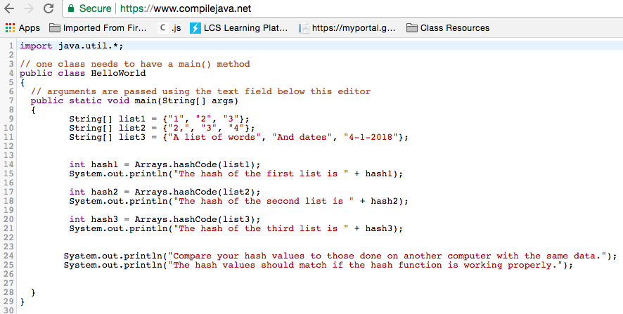

Provide a screen capture of the output of the program.

Compare your results of several hashes with those done on another computer. They should be the same results.

**Part 3: Create a Chain of Block Objects**

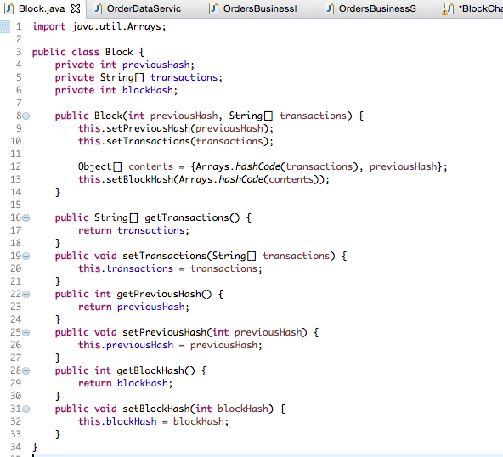

**Define the Block Class**

In this part of the exercise we will create a class called a Block. The block contains the ability to connect itself with the hash value of a previous element, making a “block chain.”

**Build a Chain of Blocks**

In the Main class, create some transactions and add them to the block chain. These transactions are simple strings. In a real block chain application, you could imagine that the strings are replaced by transaction records written in JSON data format or other types of formatted objects.

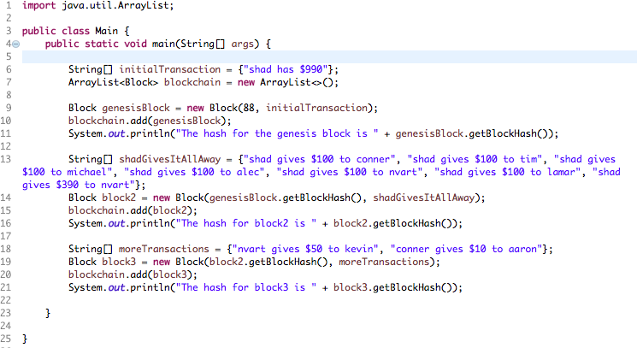

**Record the Results**

Take a screenshot of the application results. You should show the printout of the hashes after each transaction.

Record another list of transactions. You can describe the transactions as strings. Record your hash values.

|  |  |  |
| --- | --- | --- |
| **Transactions**  *Example: “Nvart gives all of her money to me.”* | **Block Hash Value** | **How Much Does Each Person Claim He/She Owns?** |
| *Shad has $100*  *Nvart has $200*  *Conner has $300*  *Tim has $400*  *Michael has $500*  *Alec has $600*  *Lamar has $700*  *Kevin has $800*  *I have $900* | -648798470  951902200  1383984123  682799901  918146607  -1842500594  1959974479  1749011544  -1496242667 | Shad: $100  Nvart: $200  Conner: $300  Tim: $400  Michael: $500  Alec: $600  Lamar: $700  Kevin: $800  You: $900 |

**Part 4: Commit Some Fraud!**

After completing the list of transactions, it is time to attempt some fraud. Make a minor change in any one of the strings in any of the transactions (change a number or change a letter). Now what are the results of the hashes that you see in the console log?

|  |  |  |
| --- | --- | --- |
| **Transactions**  Example – notice the minor change: “Nvart gives **none** of her money to me.” | **Block Hash Value** | **How Much Does Each Person Claim He/She Owns?** |
| Shad has $10  Nart has $200  Conn0r has $300  Tim has $1100  Michael have $500  Alex has $600  Lamar has $770  Kev has $800  I have $9000 | -1683496940  581987678  2133125638  -308128843  -1263467697  1674316903  1959974696  645275869  861116697 | Shad: $10  Nvart: $200  Conner: $300  Tim:$1100  Michael: $500  Alec: $600  Lamar: $770  Kevin: $800  You: $9000 |

The previous steps are based on the video tutorial “Blockchain Programming Tutorial in Java. Blockchain Demo” located within the Topic Materials.

**Conclusion**

1. Explain in your own words how hashing enables a block chain to function.
   1. By using hashing, block chain is successfully able to commit transactions securely. Cryptocurrency is an extremely lucrative financial investment, especially right now. In the online world, anything that is popular is also the most targeted by hackers. As this cryptocurrency can be exchanged online, it is likely that the currency system will be hacked, or an attempt will be made. The hashing of every transaction makes the data secure and even if the data is compromised, the hacker would have no use for the data because of the end-to-end encryption.